Module Code: ENG1501
Assignment 01
Unique Number: 12345
Name: CHARITY MASINA
Student No: 27068323
Due Date: 11/10/2025

Question 01
- William Shakespeare was born in England in 1564 English poet, playwright, and actor.
- Hamlet, Othello, King Lear, and Macbeth.

Question 2
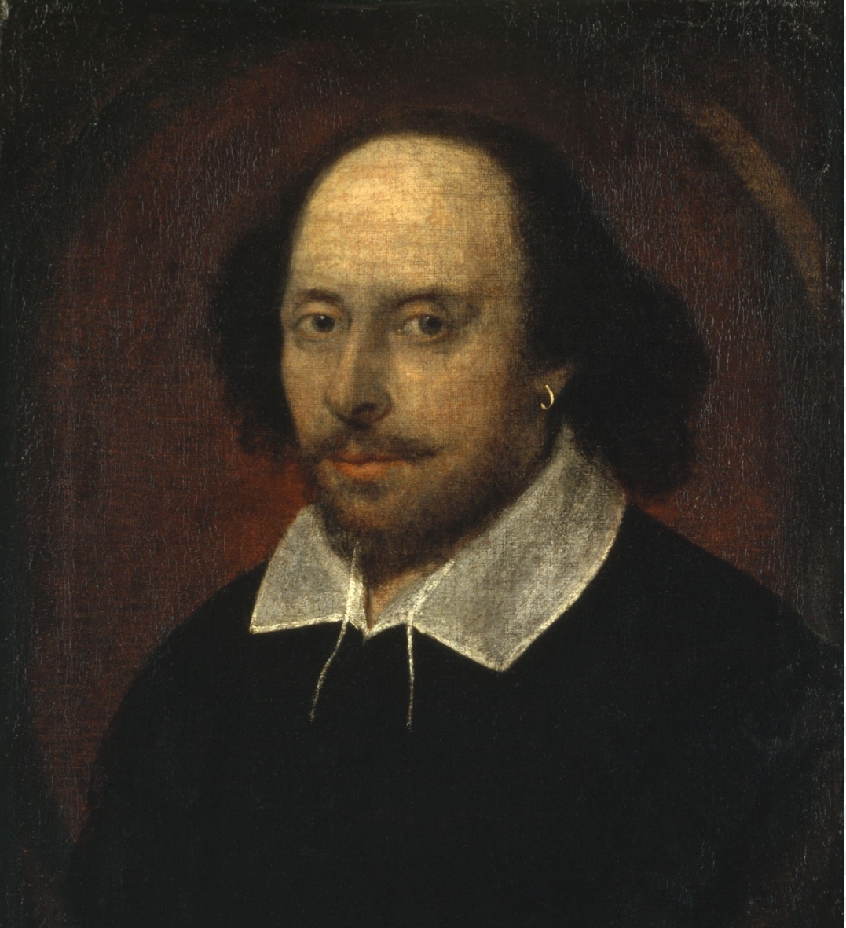
The Tragedy of Hamlet, Prince of Denmark, often shortened to Hamlet. Set in Denmark, the play dramatizes the revenge Prince Hamlet is called to wreak upon his uncle, Claudius, by the ghost of Hamlet's father, King Hamlet. Claudius had murdered his own brother and seized the throne, also marrying his deceased brother's widow. In the first act the protagonist of Hamlet is Prince Hamlet of Denmark, son of the recently deceased King Hamlet, and nephew of King Claudius, his father's brother and successor. Claudius hastily married King Hamlet's widow, Gertrude, Hamlet's mother, and took the throne for himself. Denmark has a long-standing feud with neighbouring Norway, in which King Hamlet slew King Fortinbras of Norway in a battle some years ago. Although Denmark defeated Norway, and the Norwegian throne fell to King Fortinbras infirm brother, Denmark fears that an invasion led by the dead Norwegian king's son, Prince Fortinbras, is imminent. The scene summary of Act 1 is verbatim below: “O all you host of heaven! O earth! What else? And shall I couple hell? O, fie! Hold, hold, my heart; and you, my sinews, grow not instant old, But bear me stiffly up. Remember thee! Ay, thou poor ghost, while memory holds a seat in this distracted globe. Remember thee! Yea, from the table of my memory I'll wipe away all trivial fond records.”

Question 3
Act | Scene
Act 1 | 5
Act 2 | 2
Act 3 | 4
Act 4 | 7
Act 5 | 2

