Notes for Data Capturers:
- Sub programmes indication(s):
2.5.1 the actual number of people who benefited from the Social Relief Programme.
2.5.2 (Sanitary Pads)
Different quintiles * 1-3 are the poorest Schools, farm schools and special schools.
Different quintiles * 4-5

- Responsibilities for Data: 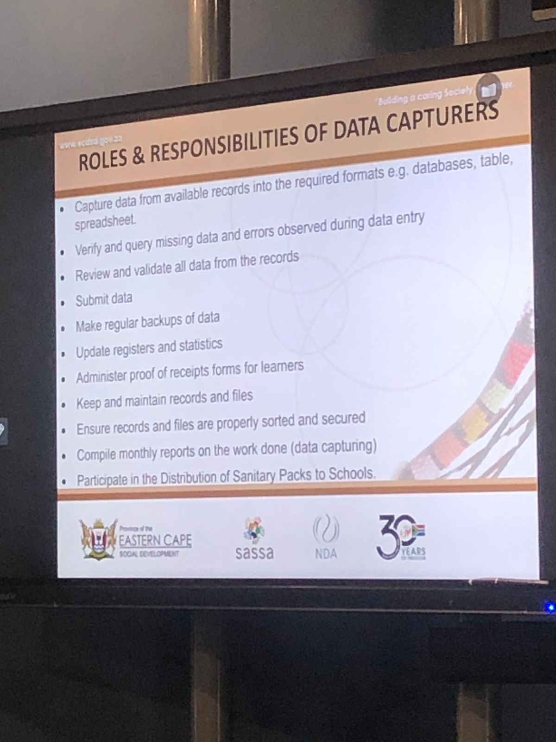

- When capturing these are the dos and donts
