“INNOVATIONS WEEKLY”
EXPLORING THE FUTURE OF TECHNOLOGY
ASSIGNMENT DUTE DATE

Article 1: The Ethical Use of Artificial Intelligence
By Elon Kroeze
Artificial Intelligence (AI) is rapidly reshaping the modern workplace. From automated recruitment systems and performance monitoring tools to AI-driven decision-making, organisations are increasingly relying on intelligent technologies to improve efficiency and productivity. However, alongside these benefits, the growing use of AI at work has revealed a darker side that raises serious ethical, social, and human concerns.
Key risks include:

- Biases in algorithms, where AI systems unfairly disadvantage certain groups in hiring, promotion, or performance evaluation.
- Job displacement and deskilling, as automation replaces routine tasks and reduces opportunities for meaningful human work.
AI has the potential to enhance work and productivity, but if left unchecked, it can deepen inequality, erode trust, and dehumanise labour. Addressing the dark side of AI in the workplace is essential to ensure that technological progress benefits not only organisations, but also the people who work within them.
Article 2: Immersive Learning – Improving Learning Experiences
By Julias Phiri
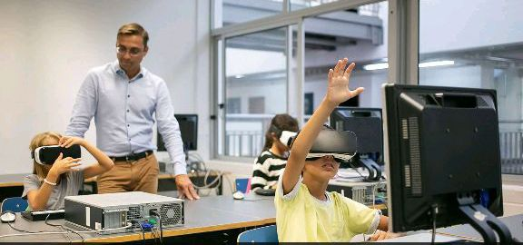

Immersive learning has rapidly emerged as a powerful evolution of e-learning in modern education. Through technologies such as virtual reality (VR), augmented reality (AR), simulations, and interactive digital environments, students can now move beyond passive content consumption to actively experiencing learning. With a suitable device and internet access, learners across the globe can engage with rich, experiential educational content without being physically present in a classroom.
How Immersive Learning Is Transforming Education:
- Learners participate in realistic simulations, virtual laboratories, and interactive 3D environments that enhance understanding and retention.
- Educators integrate immersive tools into platforms such as Moodle, Microsoft Teams, and Google Classroom to support experiential activities, assessments, and collaborative learning.
- Working professionals and students develop practical, job-ready skills through virtual training scenarios, remote labs, and immersive micro-credentials, often at their own pace.
The flexibility, accessibility, and experiential nature of immersive learning make it especially valuable in contexts where access to physical resources, laboratories, or face-to-face instruction is limited. As immersive technologies continue to advance, they are reshaping teaching and learning into more engaging, inclusive, and impactful experiences, bridging the gap between theory and practice in digital education.

Sidebar Content
📢 Did You Know? The Future of Technology Is Already Here
- 🤖 Artificial Intelligence is moving from task automation to decision support, creativity, and personalised digital assistants.
- 🌐 The Metaverse and immersive technologies (VR/AR/XR) are shaping how we learn, work, and collaborate remotely.
- 🧠 Brain–computer interfaces and wearable technologies are opening new possibilities for healthcare, accessibility, and human–machine interaction.
- 🌱 Green technologies and AI-driven sustainability tools are playing a growing role in tackling climate and energy challenges.
📅 Upcoming Future Tech Events
📌 FutureTech Africa Summit – April 18, 2026 | Johannesburg, South Africa
📌 Global AI & Ethics Forum – July 22, 2026 | Online
📌 Immersive Technologies in Education Conference – October 5, 2026 | Singapore
The future of technology is not just about smarter machines — it’s about how humans adapt, learn, and thrive alongside them.

